**Enable diagnostic logging for Azure AI services**

This guide provides step-by-step instructions to enable diagnostic logging for an Azure AI service. These logs provide rich, frequent data about the operation of a resource that are used for issue identification and debugging. Before you continue, you must have an Azure account with a subscription to at least one Azure AI service, such as [Speech Services](https://learn.microsoft.com/en-us/azure/ai-services/speech-service/overview).

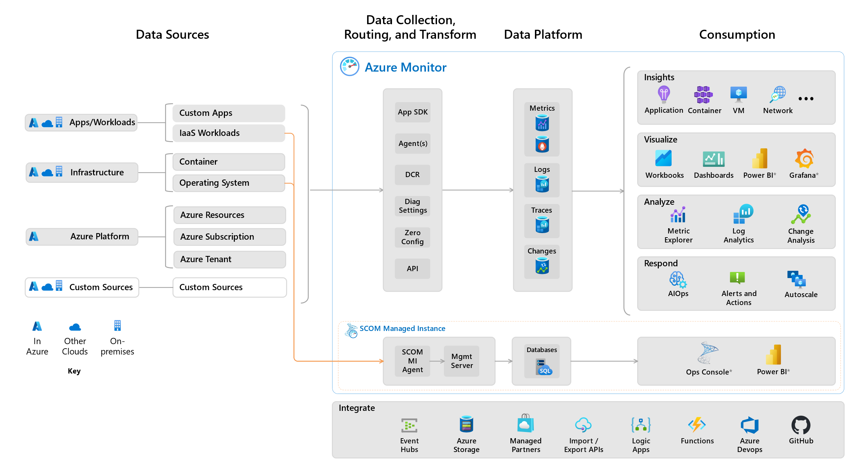

**Prerequisites**

To enable diagnostic logging, you'll need somewhere to store your log data. This tutorial uses Azure Storage and Log Analytics.

* [Azure storage](https://learn.microsoft.com/en-us/azure/azure-monitor/essentials/resource-logs#send-to-azure-storage) - Retains diagnostic logs for policy audit, static analysis, or backup. The storage account does not have to be in the same subscription as the resource emitting logs as long as the user who configures the setting has appropriate Azure RBAC access to both subscriptions.
* [Log Analytics](https://learn.microsoft.com/en-us/azure/azure-monitor/essentials/resource-logs#send-to-log-analytics-workspace) - A flexible log search and analytics tool that allows for analysis of raw logs generated by an Azure resource.

**Enable diagnostic log collection**

Let's start by enabling diagnostic logging using the Azure portal.

1. Navigate to the Azure portal. Then locate and select an Azure AI services resource. For example, your subscription to Speech Services.

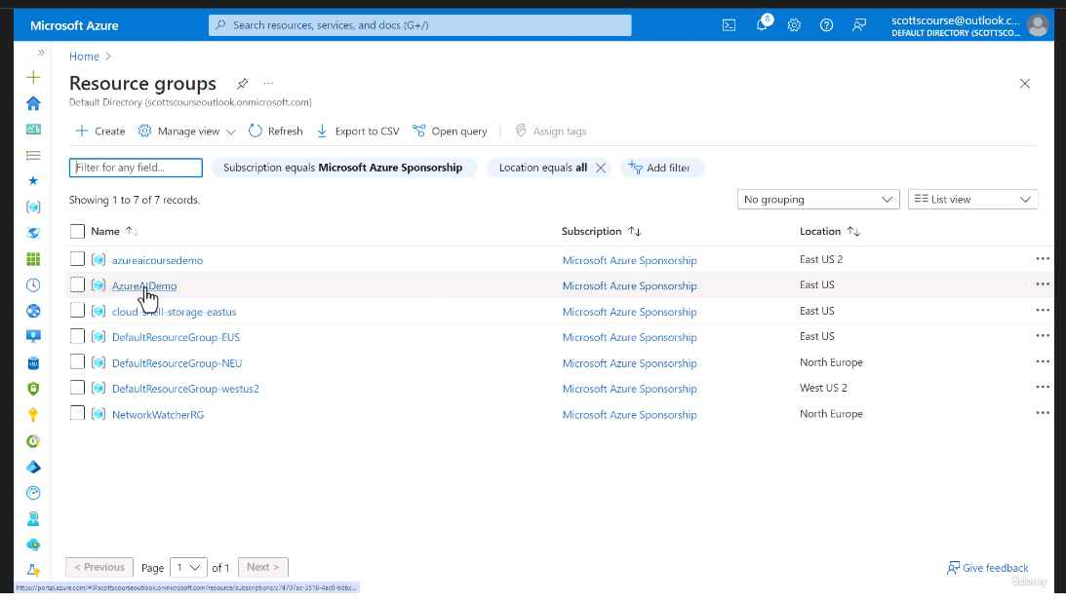

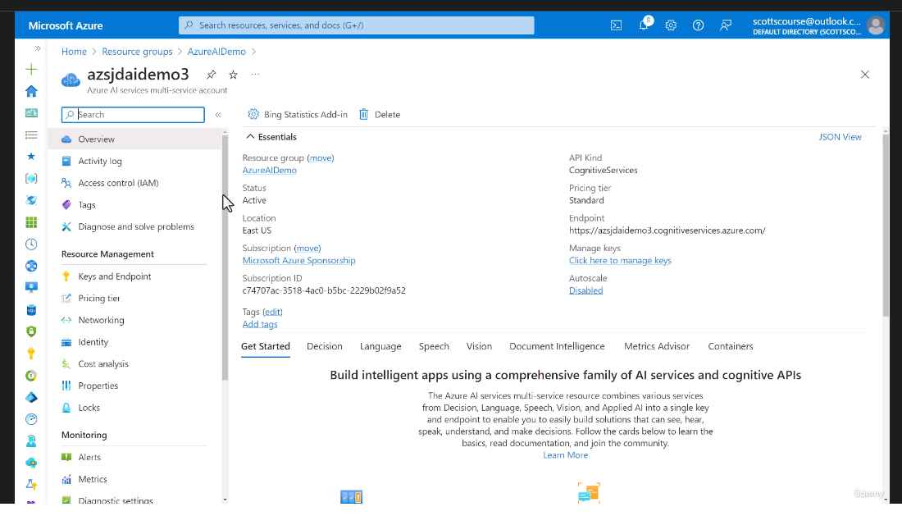

1. Next, from the left-hand navigation menu, locate **Monitoring** and select **Diagnostic settings**. This screen contains all previously created diagnostic settings for this resource. If there is a previously created resource that you'd like to use, you can select it now. Otherwise, select **+ Add diagnostic setting**.

1. On the **Diagnostic setting** setup page, perform the following actions:

* Provide a unique name for your new diagnostic setting in the **Diagnostic setting name** box.
* (Optional) In the **Metrics** section, check the **AllMetrics** setting checkbox if you want to route the resource's platform metrics to the selected log destinations. By default, platform metrics are sent automatically to Azure Monitor Metrics without any additional configuration required.
* In the **Destination details** section, perform the following operations:
  + Select **Send to Log Analytics workspace** and choose a workspace from the **Log Analytics workspace** dropdown list to send the diagnostic logs.
* Choose **Save** to apply the configuration changes.

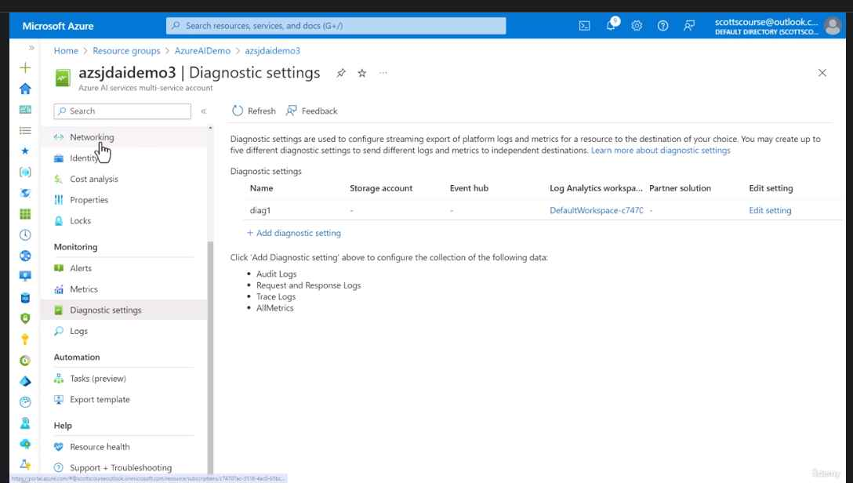

It can take up to two hours before logging data is available to query and analyze. So don't worry if you don't see anything right away.

**Generate Logs**

1. Go to Vision Studio and click on “View all resources”.

1. Select the resource (configured Log Analytic Workspace) and click on “Select as default resource”.

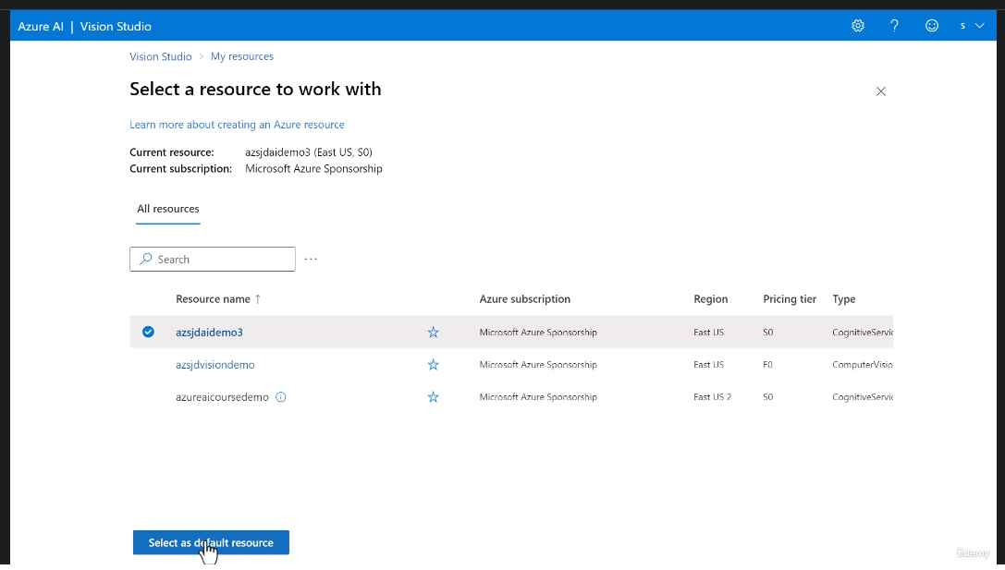

1. Perform few “Extract text from images” operation to send logs.

